Vocabulary.

Nature  
**Look at these pictures. Can you guess what landscape features are shown? Read all three answers carefully and decide which is the correct one.**

1. 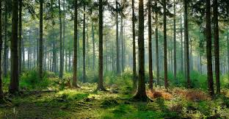

* Plain
* Forest
* Shrubbery

2. 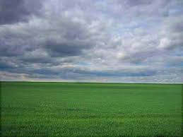

* Hill
* Plain
* Mountain

3. 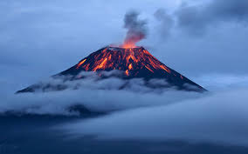

* Mountain
* Volcano
* Hill

4.  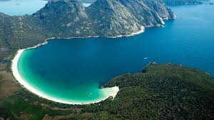

- flat  
- bay  
- hill

5. 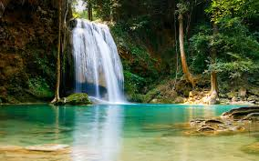

* Lake
* Waterfall
* Stream

6. 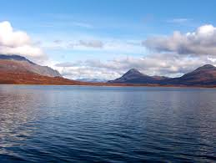

* Sea
* River
* Lake

7. 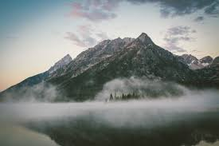

* Hill
* Plain
* Mountain

8. 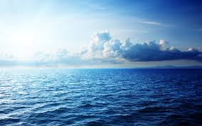

* Sea
* Lake
* River

9. 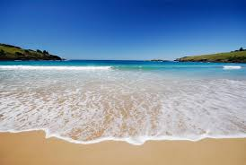

* Beach
* River
* Lake

10. 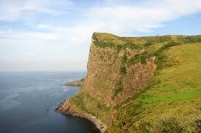

* Plain
* Cliff
* Hill

11. 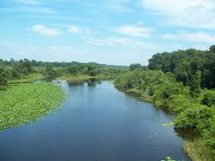

* River
* Bay
* Lake

12. 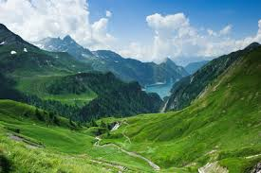

* Plain
* Valley
* forest

All about energy and environment. Definitions  
**Read the sentences. Choose the right word or phrase for these definitions.**

1. Electricity ​produced using wind ​turbines:   
- land farm  
- wind farm

2. Places have no one in it  
- unoccupied sites  
- landfill sites

3. The air, land, and water where people, animals, and plants live:  
- environment  
- landfill sites

4. A fuel such as coal or oil that is obtained from under the ground:   
- gases  
- fossil fuels

5. Produce energy, usually electricity, that is used to provide light, heat, etc:   
- generate power  
- nuclear power

6. A machine with long parts at the top that are turned by the wind, used to make electricity:  
- land turbine  
- wind turbine

7. Hydroelectric ​power (= the ​production of ​electricity by the ​force of ​fast ​moving ​water):  
- hydropower  
- solar power

8. A ​group of ​wind ​turbines (= ​tall ​structures with ​blades that are ​blown by the ​wind) that are used for ​producing ​electricity:   
- wind farm  
- farm

9. Damage caused to water, air, etc by harmful substances or waste:  
- pollution  
- protection

10. A place where the production of the energy is released when the nucleus (= central part) of an atom is divided:  
- water station  
- nuclear power station

11. Control the way that wind is going or facing:  
- water direction  
- monitor wind direction

Ecology. Definitions  
**Read the sentences. Choose the right word or phrase for these definitions.**

1. Protection, or something that provides protection against attack or criticism:  
- defence  
- deference

2. Things that are not wanted, especially what remains after you have used something:  
- wastes  
- sites

3. The relationship between living things and the environment, or the scientific study of this:  
- ecology  
- protection

4. Relating to the air or to the atmosphere:  
- atmospheric  
- scaremongering

5. A sudden movement of the Earth's surface, often causing severe damage:  
- flood  
- earthquake

6. Damage caused to air by harmful substances or waste:  
- land pollution  
- air pollution

7. The power to affect how someone thinks or behaves, or how something develops:  
- influence  
- protect

8. A business or organization:  
- wastes  
- enterprise

The problems of nature. Definitions  
**Read these definitions. Write the word or phrase for them.**

1. To destroy something completely:

2. Poisonous:

3. To change a situation or change the order of things so that it becomes the opposite:

4. Animals or plants which may soon not exist because there are very few now alive

5. The natural environment of an animal or plant:

6. Animals, birds, and plants living in their natural environment:

7. To make someone suffer by doing something unpleasant to them:

8. A chemical that is used to kill insects which damage plants:

9. A hard, white substance from the tusks (= long teeth) of some animals, such as elephants (= large, grey animals):

10. All the living things in an area and the way they affect each other and the environment:

Reading.

Ecological problems  
**Read the text about ecological problems in the world.**

Ecological problems are causing great damage to our environment. Among the most urgent ones are the ozone layer, acid rains, global warming, toxic pollution of atmosphere, disappearance of forests, contamination of underground waters by chemical elements, destruction of soil in some areas, and threat to some flora and fauna representatives.

The Earth is the home to millions of different kinds of living things, which make up the complex world of nature. Nowadays people try to change their habitats to suit their own needs – to create farmlands or build cities. They create pollution and destroy wildlife habitats by digging the ground up for mining, or by building roads through them. A quarter of all the plants in the world are known to be in a danger or threatened with extinction. There are different types of pollution: water pollution, air pollution, ground pollution and nuclear pollution.

Acid rain falls when poisonous gases from power stations and vehicle exhausts mix with oxygen and moisture in the air. These gases become the part of the water cycle and may be carried a long way by the wind before they fall as acid rain, which kills wildlife in lakes, rivers, and forests, and damages the surrounding plant life.

World temperatures are currently rising every year. This so called global warming is caused by the building of gases and water vapour in the atmosphere. As the planet warms up, the polar ice caps will start to melt. This could cause sea levels to rise and many habitats will disappear under water.

Ecological problems have no borders. However, environment disasters can be avoided if people broaden ecological education and every person understands that the beauty of nature is extremely fragile. Governments must take serious actions against pollution.

**Choose *true*or *false*:**

1. The Earth has never been the home to millions of different kinds of living things.

2. A half of all the plants in the world are known to be in a danger or threatened with extinction.

3. Environment disasters can be avoided if people broaden ecological education.

4. People never create pollution and destroy wildlife habitats.

5. Acid rain never falls because of gases from power stations.

6. Ecological problems are causing great damage to our cars.

7. A quarter of all the plants in the world are known to be in a danger or threatened with extinction.

8. Ecological problems are causing great damage to our environment.

Environmental problems  
**Read the text about environmental problems.**

Since ancient times Nature has served Man, being the source of his life. For thousands of years people lived in harmony with environment and it seemed to them that natural riches were unlimited. But with the development of civilization man's interference in nature began to increase. Large cities with thousands of smoky industrial enterprises appear all over the world today. The products of their activity pollute the air we breathe, the water we drink, the land we grow grain and vegetables on.

Every year world industry pollutes the ahmosphere with about 1000 million tons of dust and other harmful substances. Many cities suffer from smog. Vast forests are cut and burn in fire. Their disappearance upsets the oxygen balance. As a result, some rare species of animals, birds, fish and plants disappear forever, a number of rivers and lakes dry up.The pollution of air and the world's ocean, destruction of the ozone layer is the result of man's careless interaction with nature, a sign of the ecological crises.The most horrible ecological disaster befell Ukraine and its people after the Chernobyl tragedy in April 1986. About 18 percent of the territory of Belarus were also polluted with radioactive substances. A great damage has been done to the agriculture, forests and people's health. The consequences of this explosion at the atomic power station are tragic for the Ukrainian, Belarussian and other nations.

Environmental protection is of a universal concern. That is why serious measures to create a system of ecological security should be taken. Some progress has been already made in this direction. As many as 159 countries - members of the UNO - have set up environmental protection agencies. Numerous conferences have been held by these agencies to discuss problems facing ecologically poor regions including the Aral Sea, the South Urals, Kuzbass, Donbass, Semipalatinsk and Chernobyl. An international environmental research centre has been set up on Lake Baikal. The international organisation Greenpeace is also doing much to preserve the environment. But these are only the initial steps and they must be carried to protect nature, to save life on the planet, not only for the sake of the present, but also for the future generations.

**Choose *true* or *false*:**

1. Large cities with thousands of smoky industrial enterprises disappear all over the world today.

2. Vast forests are cut and burn in fire.

3. The most horrible ecological disaster befell Spain and its people in April 1986.

4. For thousands of years people lived in harmony with environment.

5. Every year world industry pollutes the ahmosphere with about 1000 million tons of dust and other harmful substances.

6. Many cities suffer from smog.

7. The products from factories pollute the air we breathe, the water we drink, the land we grow grain and vegetables on.

Global warming  
**Read the text about global warming.**

**Global warming.**

Global warming has become a serious problem in modern world. It is referred to potential changes in climate, which can lead to the rise of global temperature. This term has been presented by scientists. They work hard trying to solve the problem. Otherwise, global warming can produce really dangerous climatic changes apart from a rise in temperature. For example, over the past 100 years the average temperature rise was about 1 degree. According to some scientists global warming is the result of the industrial revolution. If it continues, it can destroy our civilization.

One of the most important reasons of global warming is air pollution. More and more factories are being built in different countries. By burning oil, coal, gasoline, even natural gas, they add more carbon dioxide to the atmosphere. Cars also influence the atmosphere badly by burning many liters of oil and releasing harmful gases into the air. As a result, the ozone layer of our Earth is being destroyed.

All these activities unfavourably change the Earth’s heat balance. This is what we get in return: the ground becomes very dry, a lot of rivers and lakes dry up, the forests start burning, the glaciers melt, people and animals start to faint. And these are not all the outcomes of global warming. Nature becomes really angry with us. We need to become more attentive and caring to it if we want to save our planet.

There are several ways to do it. At first, we should start saving natural resources, such as water, wood, land and air. It would be a good idea to recycle things that we do not use anymore. Cars should switch to electric refueling, while factories should not isolate carbonic gas. We should also reduce the use of different sprays and lacquer, which destroy the ozone layer. If we take these simple measures, we might save our planet.

**Choose *true* or *false*:**

1. According to some scientists global warming is the result of the animals' evolution.

2. Now the ozone layer of our Earth is being destroyed.

3. The writer considers that people should reduce the use of different sprays and lacquer.

4. Global warming has become a simple problem in modern world.

5. Cars also influence the atmosphere well.

6. The writer thinks that we need to become more careless to our planet.

7. The writer thinks that nature becomes really angry with us.

8. Global warming can produce dangerous climatic changes apart from a rise in temperature.

9. Cars also influence the atmosphere badly.

Environment  
**Read the article and answer the questions below.**

**The five most important things you can do for the environment.**

Some of these strategies may seem a little radical, but they are among the most valuable actions you can take to protect and preserve Earth’s environment. Have Fewer Children—or None Overpopulation is arguably the world’s most serious environmental problem, because it exacerbates all of the others. The global population grew from 3 billion in 1959 to 6 billion in 1999, an increase of 100 percent in just 40 years. In addition to keeping your own family small, consider supporting programs that fight hunger and poverty, improve sanitation and hygiene, or promote family planning and reproductive health in developing nations. Use Less Water—and Keep It Clean Fresh, clean water is essential to life—no one can live long without it—yet it is one of the scarcest and most endangered resources on our increasingly fragile planet. Use only as much water as you need, don’t waste the water you do use, and avoid doing anything to taint or endanger water supplies. Eat Responsibly Eating locally grown food supports local farmers and merchants in your own community as well as reducing the amount of fuel, air pollution and greenhouse gas emissions required to move the food you eat from the farm to your table. Eating organic meat and produce keeps pesticides and chemical fertilizers off your plate and out of rivers and streams. Conserve Energy—and Switch to Renewable Energy Walk, bike and use public transportation more. Drive less. Not only will you be healthier and help to preserve precious energy resources, you’ll also save money. Whenever possible, choose renewable energy over fossil fuels. Reduce Your Carbon Footprint Online calculators can help you measure and reduce your personal carbon footprint. In addition to lowering your own carbon footprint, let your government officials know that you expect them to take action on this issue—and keep the pressure on until they do.

**Choose *true* or *false*:**

**1.**Some of the given suggestions may seem extreme measures.

**2.**Fresh, clean water is one of the most common resources on our planet.

**3.**By preserving energy resources you might also become healthier and save money.

**4.**Walking and cycling or using public transportation slightly reduces the amount of pollution and greenhouse gas emission.

**5.**Using public transportation once in a while increases the overall health of the person.

**6.**BRT is bus rapid transportation.

**7.**The global population doubled in just 40 years.

**8.**Eating locally grown food reduces the negative impact on environment caused by transportation of food from the farm to the consumer.

**9.**Informing your local government officers about your views on the carbon emissions only once is enough.

**10.**Deflated tires improve the performance of your car allowing you to drive smart.

**11.**Reusable shopping bags do not need to be thrown away after each use.

**12.**By paying your bills online you are contributing to the prevention of the clearance of naturally occurring forests.

Nature and polar bears  
**Read the article about polar bears.**

**Polar bear makes the list.**

In Spring 2008, the polar bear was placed on the endangered species list. According to the Endangered Species Act, an endangered species is an animal that is likely to face extinction in its natural habitat. Polar bears have been categorized as a "threatened" species. A "threatened" species is one that is expected to become "endangered" in the foreseeable future.

The polar bear is the first animal that has been classified as endangered due primarily to global warming. Global warming is caused by carbon dioxide and other greenhouse gases that become trapped in the atmosphere. Heating homes, driving cars, and burning garbage all require fossil fuels that lead to global warming.

The polar bear's habitat is more vulnerable to global warming than many other species. Polar bears live mainly on the sea ice in the Arctic. This is where they hunt for fish and build up fat reserves. When the ice melts many polar bears move to land and live off their stored fat. In the Arctic, global warming is causing the ice to melt slightly earlier and form slightly later. This results in a shorter feeding season for the polar bear. Some risk their lives to find ice. If they have to swim too far they will drown from exhaustion and hunger.

It is not only the polar bear that is at risk in the Arctic. Every species of plant, animal, and insect there is threatened by global warming. It is important that animals such as the polar bear make it onto the endangered species list. Once they are on the list there are laws that protect these animals from being hunted for food or sport. In fact, it is rare for a species to go extinct after they make the list. Sadly many species do go extinct while waiting for consideration.

**Choose *true* or *false*:**

**1.** A 'threatened' species is one that is expected to die out in its natural surroundings.

**2.** When polar bears live on land, they live off their stored fat.

**3.** Being placed on the endangered species list means that these animals will be protected from hunting for food or sport.

**4.** According to the article, an endangered species is one that will likely to die out in its natural surroundings.

**5.** When ice melts, polar bears live and hunt in the sea.

**6.** Polar bears are the only species at risk in the Arctic.

**7.** Polluted water poses the greatest threat to polar bears today.

**8.** Unfortunately many species become extinct while waiting for consideration.

**9.** The global warming is the main reason why polar bears have been classified as endangered.

**10.** It is very common that species go extinct after they make the list.

Green packaging  
**Read the text about green packaging.**

Manufacturers are currently competing with each other to produce a form of green packaging. Packaging is an important part of marketing these days, but much of it is a threat to the environment. There are two reasons for this. The production of such packaging uses up a great deal of energy and cartons, wrappers, etc are often difficult to dispose of when they become waste material.

People in most countries have become aware of the damage which modern living is doing to the environment, and many of them are concerning themselves with the conservation of the environment for future generations. Thus, both politicians and scientists are now looking at the issues of the energy-saving and waste disposal with a view to making them more environmentally-friendly.

As far as packaging is concerned, it is vital that it is either recyclable or biodegradable. For example, instead of throwing out newspaper and glass bottles with their household rubbish, people in several countries are being encouraged to put these in special containers to allow the material to be recycled. Some household waste, such as vegetable peelings, is naturally biodegradable and so decomposes gradually until it disappears.

Man-made goods are not so easily disposed of. Goods and packaging made of plastic create waste material that is particularly difficult to get rid of. This means that huge landfill sites have to be dug out so as to bury the plastic waste underground, possibly causing problems for future generations.

Just as much of a problem is industrial waste, since the effluent from factories often contains chemicals, which can lead to the pollution of water supplies. Waste from factories has to be monitored carefully in order to avoid this.

Technological advances using nuclear power have added to the waste problem. The disposal of nuclear waste causes particular concern because it is radioactive and so possibly dangerous to life.

The high standard of living, which the people of many countries now enjoy, has resulted in a huge increase in waste material. This could have a terrible effect on the ecology of the planet. There is no doubt that urgent action must be taken to save our environment from possible disaster.

**Choose *true* or *false:***

1. Manufacturers are currently competing with each other to produce a form of red packaging.

2. People in most countries do not worry about the damage which modern living is doing to the environment.

3. Goods and packaging made of plastic create waste material that is particularly difficult to get rid of.

1. Packaging is an important part of marketing these days, but much of it is a threat to the environment.

4. Goods and packaging made of glass create waste material that is particularly easy to get rid of.

5. Technological advances using nuclear power have added to the waste problem.

What happens to climate?  
**Read the text about the problems of climate on our planet.**

Experts in climatology and other scientists are becoming extremely concerned about the changes to our climate which are taking place. Admittedly, climate changes have occurred on our planet before. For example, there have been several ice ages or glacial periods.

These climatic changes, however, were different from the modern ones in that they occurred gradually and, as far as we know, naturally. The changes currently being monitored are said to be the result not of natural causes, but of human activity. Furthermore, the rate of change is becoming alarmignly rapid.

The major problem is that the planet appears to be warming up. According to some experts, this warming process, known as global warming, is occurring at a rate unprecedented in the last 10,000 years. The implications for the planet are very serious. Rising global temperatures could give rise to such ecological disasters as extremely high increases in the incidence of flooding and of droughts. These in turn could have a harmful effect on agriculture.

It is thought that this unusual warming of the Earth has been caused by so-called greenhouse gases, such as carbon dioxide, being emitted into the atmosphere by car engines and modern industrilal processes, for example. Such gases not only add to the pollution of the atmosphere, but also create a greenhouse effect, by which the heat of the sun is trapped. This leads to the warming up of the planet.

Politicians are also concerned about climate change and there are now regular summits on the subject, attended by representatives from around 180 of the world’s industrialized countries. Of these summits, the most important took place in Kyoto in Japan in 1997. There it was agreed that the most industrialized countries would try to reduce the volume of greenhouse gas emissions and were given targets for this reduction of emissions.

It was also suggested that more forests should be planted to create so-called sinks to absorb greenhouse gases. At least part of the problem of rapid climate change has been caused by too drastic deforestation.

Sadly, the targets are not being met. Even more sadly, global warnings about climate changes are often still being regarded as scaremongering.

**Read the sentences. Change the incorrect word or phrase into the correct one and write only the correct variant, not the whole sentence. If you think that the sentence is correct, write *OK*.**

***Example 0.****Experts in climatology and other scientists are becoming extremely concerned about the changes to our climate which are taking place. OK*

1. Admittedly, climate changes have occurred on our planet before.

2. Rising global problems could give rise to such ecological disasters as extremely high increases in the incidence of flooding and of droughts.

3. Politicians are also concerned about climate change and there are now regular summits on the subject, attended by representatives from around 180 of the world’s industrialized countries.

4. For example, there have been several ice ages or glacial times.

5. The implications for the trees are very serious.

6. According to some experts, this warming process, known as global warming, is occurring at a rate unprecedented in the last 10,000 years.

7. Of these summits, the most important took place in Kyoto in Russia in 1997.

8. The changes currently being monitored are said to be the result not of natural changes.

9. It was also suggested that more forests should be planted to create so-called sinks to absorb chemicals.